MINISTRY OF TRANSPORT  AND INFRASTRUCTURE  ----------**---------- |  | REPUBLIC OF MALI  One People – One Goal – One Faith  ----------**----------
GENERAL SECRETARIAT
----------**----------
GENERAL DIRECTORATE
OF ROADS
---------**----------
National Coordination Unit of the Mali-NSS Program

Early Market Engagement (EME) Notice for the rehabilitation and paving work on the Diéma-Sandaré section
Subject: Mali Road Infrastructure Connectivity and Resilience Improvement Program
(Mali Nafa Soro Siraw, Mali-NSS)
P507921
Early Engagement Market on Transport Infrastructure
Published on June 2, 2025
Consultation venue: Bamako, at the World Bank offices, Waly Diawara Building, Avenue du Mali, Hamdallaye ACI 2000 – Phone: (+223) 20 70 22 00, on Tuesday, June 24, 2025 at 10:00 a.m. GMT. A MICROSOFT TEAMS link is included for all participants wishing to attend the meeting virtually.
Introduction
The Ministry of Transport and Infrastructure (MTI) intends to initiate a dialogue with market stakeholders to gather insights and feedback regarding the rehabilitation and paving of the Diéma–Sandaré section (137.668 km) along the Bamako–Dakar Corridor (Northern route), financed by the World Bank under the Mali Nafa Soro Siraw (Mali-NSS) Project. This consultation aims to assess market interest, analyze feasibility, and refine project design to ensure its success.
Objectives of the Consultation
- Assess market interest in the proposed project and forthcoming contracts.
- Collect feedback on key requirements, project risks, and opportunities.
- Identify potential private sector partners.
- Optimize project structuring and improve the bidding documents (BDs) to maximize national and international participation ahead of their official launch.

Program Overview
Objective: To improve climate-resilient connectivity of Mali’s priority road corridors.
Key Works under the Mali-NSS Program include:
- Rehabilitation and paving of the 137.668 km Diéma–Sandaré section of the Bamako–Dakar Northern Corridor, in two lots. This also includes the development of 11 km of urban roads, rehabilitation of a modern toll and weighing station in Diéma, and construction of a truck parking area in Sandaré. Supervision and control will be managed by two separate firms for the road works, while one firm will oversee urban roadworks in both cities.
- Development of 200 km of rural roads, along with hydraulic and ancillary infrastructure in the Nioro and Kayes regions, within the area of influence of the Diéma- Sandaré section of the Bamako – Dakar Northern Corridor.
Subsequent phases of the program in Mali will involve the rehabilitation and paving of various sections of the Bamako–Dakar Northern Corridor, which are currently in an advanced state of deterioration (see sections highlighted in orange on the map below). These works may be implemented in partnership with other technical and financial partners, including the African Development Bank, the Islamic Development Bank, the West African Development Bank, and the Japan International Cooperation Agency.
The assessment of the entities responsible for project implementation has, at this stage, identified the country’s public procurement system as a key source of risk. These include potential delays, poor communication, limited competition, and inadequate contract management, all of which may affect the efficiency of project execution.
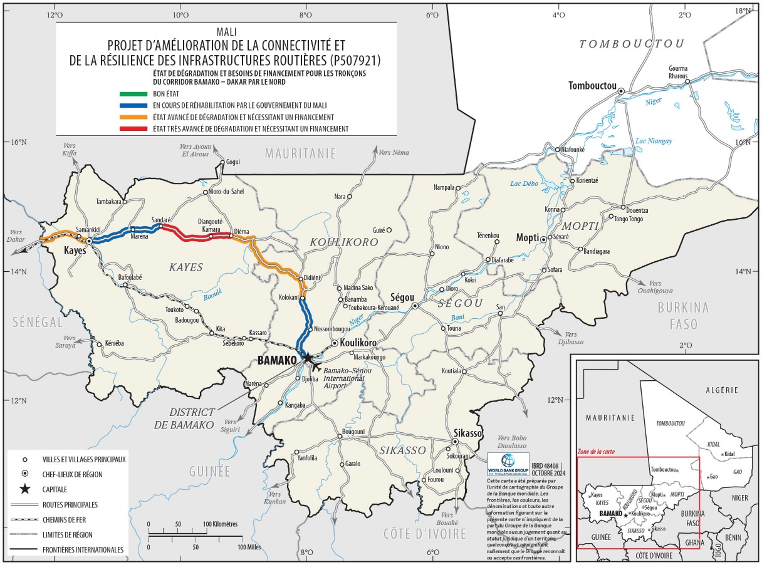

Market Risks ( the risks mentioned are not exhaustive )
- Technical Risk: The deterioration of the road due to overloading represents a major technical challenge. Although the legally permitted axle load is 13 tons, in practice this limit is frequently exceeded, often reaching double the threshold. The enforcement of Regulation 14, which has already commenced, serves as a mitigating measure to address this issue.
- Logistics Risk: Massive rock quarries and laterite are often far from project sites. An appropriate supply plan will be developed and incorporated into the contracts, including transport risk mitigation measures.
- Security risks: The project intervention area faces significant security threats and exposure to risks for project personnel and labor, project assets, as well as for beneficiaries and surrounding communities. To mitigate these inherent risks, the project will adopt a conflict-sensitive approach in its design. A Security Risk Assessment and a Security Risk Management Plan have been prepared and deemed satisfactory. These documents will be regularly updated until project closure by a security specialist, who will identify the most stable zones to guide the phased deployment of civil engineering.
- Specific Environmental and Social Risks: The main environmental and social risks and impacts identified in the implementation of civil engineering along the Diéma–Sandaré section of the Bamako–Dakar Northern Corridor under the Mali-NSS program include, among others: air quality degradation; water contamination; deforestation; disruption of wildlife habitats and peace; destruction of fauna habitats; spread of occupational diseases and STIs/HIV/AIDS; gender-based violence (GBV), sexual exploitation and abuse (SEA), sexual harassment (SH), and/or violence against children (VAC); accidents involving residents (especially children and animals); obstruction of mobility for local populations and transporters; challenges in recruiting local labor; limited community engagement; instability due to the volatile security context in the project area; and involuntary resettlement of project-affected persons and so on. To address these risks and integrate climate resilience aspects, the following environmental and social safeguard instruments have been prepared in accordance with national regulations and World Bank procedures. The main instruments developed include the Environmental and Social Impact Assessment (ESIA), including the Environmental and Social Management Plan (ESMP); the Resettlement Action Plan (RAP); the Labor Management Procedures (LMP); the Security Risk Assessment (SRA), including the Security Risk Management Plan (SRMP); the Stakeholder Engagement Plan (SEP); and the GBV/SEA/SH Action Plan. All instruments have been disclosed, except for the Security Risk Assessment (SRA) and the Security Risk Management Plan (SRMP), for which only the executive summary has been published. The GBV/SEA/SH Action Plan, prepared with an annexed Code of Conduct, includes measures to address issues related to Sexual Exploitation and Abuse (SEA), Sexual Harassment (SH), and Gender-Based Violence (GBV). A GBV Specialist will be recruited to update the action plan throughout the duration of the project and will also support the handling of reported SEA/SH/GBV incidents within the project's grievance redress mechanism.
- Banking Transaction Risks: Contractors awarded contracts under the project will preferably be paid through direct payments, with the project’s designated account as a secondary option. In both cases, the transactions are subject to foreign exchange rate fluctuations, which may result in financial gains or losses. Another risk is the potential delay in the settlement of transactions, especially international payments, which often involve multiple intermediary (correspondent) banks. These delays are further extended by anti-money laundering compliance checks. Additionally, the overall cost of transactions is increased due to the cumulative fees charged by intermediary banks.
Participation Modalities
Interested parties are invited to attend the Early Market Engagement Meeting on Tuesday, June 24, 2025, either in-person or virtually, from 10:00 a.m. to 12:00 p.m. (Mali time) at the World Bank offices in Bamako. Only companies that have expressed interest via email will be invited and sent the agenda.
MICROSOFT TEAMS connection link: https://teams.microsoft.com/l/meetup-join/19%3ameeting_OTRiYjFkYmEtYTcyOC00MGM2LThmNDItZjU0MTVlYWIxZWQ1%40thread.v2/0?context=%7b%22Tid%22%3a%2231a2fec0-266b-4c67-b56e-2796d8f59c36%22%2c%22Oid%22%3a%224274172a-99da-4973-af0e-8e419cf5cce4%22%7d
Meeting ID: 239 014 459 670 8
Passcode: gY29cY74

+1 509-408- 0991,, 659686035# United States, Liberty Lake
Phone conference ID: 659 686 035#
Join on a video conferencing device
Tenant key: wbg@m.webex.com
Video ID: 119 172 534 1
More info
For organizers: Meeting options | Reset dial-in PIN
Next Steps
The information gathered will enable the Ministry of Transport and Infrastructure to fine-tune the project’s modalities implementation strategy and procurement approach. Any formal procurement process will be communicated through official channels.
Contact
For any further information or to express your interest, please contact:
The Acting Coordinator of the National Coordination Unit Mr Daouda M. KONE of Mali-NSS, UNC, located at Medina- Coura Rue 47, Porte 212, Phone.: 20.21.57.25 & 20.21.40.33, Fax: 20.21.92.30; E-mail: uncpaar5@gmail.com Bamako, Republic of Mali.
Disclaimer
Participation in this early market engagement does not confer any advantage in future procurement process. This is not a call for tenders or a prequalification exercise. All information received will be treated confidentially and used solely for market analysis and procurement planning.

The Acting Coordinator of the National Coordination Unit
Deputy Coordinator

Daouda Moussa KONE
Knight of the National Order

For more information on the project, please visit www.ucnmali.com

